**Kol simcha torah gazette**

**For parshas nasso 5784**

Volume 8 Issue 38 (Whole #398) 9 Sivan 5784/ June 15, 2024

**Printed L’illuy nishmas Nechama bas R’ Noach, a”h**

For a free subscription, please forward your request to [***keren18@juno.com***](mailto:keren18@juno.com)

***Past emails can be found on the website ShabbosStories.com under Brooklyn Torah Gazette***

**Rabbi Moshe Kotlarsky, 74, Beloved Rabbi Traveled the Globe Tirelessly to Expand Chabad-Lubavitch’s Outreach**

**By Chabad.org Staff**

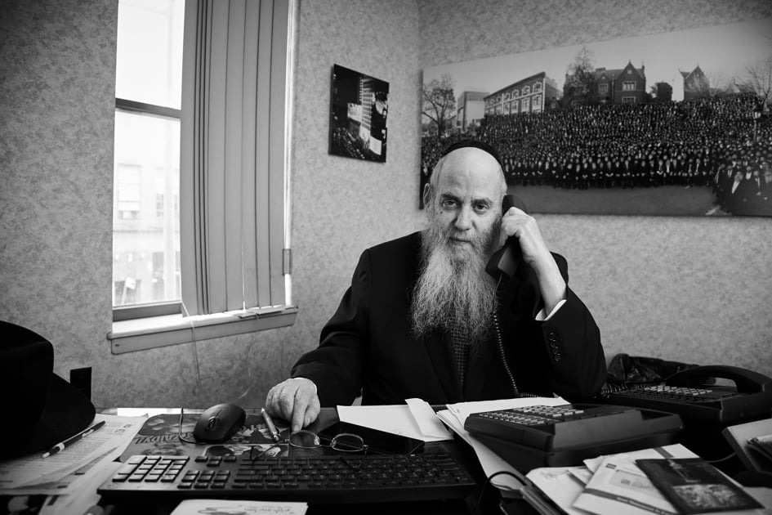

**Rabbi Moshe Kotlarsky Photo** *Credit: Marko Dashev*

Rabbi Moshe Kotlarsky, the energetic vice chairman of Merkos L’Inyonei Chinuch, the educational arm of the Chabad-Lubavitch movement, passed away after a lengthy illness on Tuesday, June 4 (27 Iyar). He was 74, four days shy of his 75th birthday.

Kotlarsky was instrumental in growing Chabad’s global footprint. With an endearing personality and ability to easily connect with others, Kotlarsky encountered thousands of people in his decades of peripatetic travel on behalf of [Chabad-Lubavitch](https://www.chabad.org/library/article_cdo/aid/244369/jewish/About-Chabad-Lubavitch.htm), serving alternatively as rabbi, fundraiser and friend.

Kotlarsky became well-known for his role in the annual Kinus Hashluchim, or [International Conference of Chabad-Lubavitch Emissaries](https://www.chabad.org/search/keyword_cdo/kid/16516), directing an army of planners, staff and volunteers to ensure every detail of the massive event was perfect. As [Chabad](https://www.chabad.org/library/article_cdo/aid/244369/jewish/About-Chabad-Lubavitch.htm)’s institutional network expanded over the years to almost [6,000 emissary couples](https://www.chabad.org/library/article_cdo/aid/244373/jewish/The-Shliach-Emissary.htm) in more than 100 countries worldwide, so did the Kinus.

**The Largest Sit-Down Dinner in the**

**New York Metropolitan Area**

Its banquet eventually became the largest sit-down dinner in New York City, outgrowing all its formal venues. [In 2023 more than 6,500 Chabad emissaries and their guests gathered](https://www.chabad.org/article.asp?aid=6171399) at the New Jersey Convention Center.

Kotlarsky would emcee the banquet annually, [calling the roll of Chabad emissaries](https://www.chabad.org/multimedia/video_cdo/aid/6171558/jewish/International-Roll-Call-5784.htm) by country and state, memorably bringing it to a crescendo with a call for “spontaneous dancing.”

Though comfortable in the spotlight, Kotlarsky also worked tirelessly behind the scenes. When in need of communal advice or facing personal hardship, emissaries knew they could count on Kotlarsky for his mentorship and support. His dedication to projects large and small, while remembering to bring chocolate for far-flung emissary children, earned him affection and respect among generations of emissary families.

**Messenger**

Rabbi Moshe Yehuda Kotlarsky was born on May 28, 1949 (1 Sivan, 5709), in Brooklyn, to Rabbi Tzvi Yosef and Golda Kotlarsky. While his mother was American-born, his father was a survivor from Poland who lost most of his family in the Holocaust. Rabbi Tzvi Yosef studied in Yeshivat Chachmei Lublin and then Tomchei Temimim-Lubavitch in Warsaw and Otwock, escaping the Nazi onslaught with the help of a [visa issued by Japanese diplomat Chiune Sugihara](https://www.chabad.org/parshah/article_cdo/aid/3592988/jewish/The-Japanese-Hero-Who-Saved-My-Grandfather-From-the-Nazis.htm), which allowed him to find refuge in occupied Shanghai.

Kotlarsky was raised in Crown Heights and attended yeshivah there before continuing his studies in Montreal. Even as a young [yeshivah](https://www.chabad.org/library/article_cdo/aid/4407857/jewish/What-Is-a-Yeshiva.htm) student, he actively participated in the Rebbe’s mitzvah campaigns. In Montreal, Kotlarsky once persuaded the famous Yiddish comedian Shimon Dzigan to wear *tefillin*, which moved Dzigan so much that he was late for his show. Dzigan explained to the audience that he couldn’t refuse a request from a Lubavitcher yeshivah student to wear [*tefillin*](https://www.chabad.org/library/article_cdo/aid/1918251/jewish/What-Are-Tefillin.htm), and the emotional experience caused his makeup to run.

Kotlarsky married Rivka Kazen in 1970. Like so many young Chabad Chassidim, the Kotlarskys expressed to [the Rebbe, Rabbi Menachem M. Schneerson](http://therebbe.com/), of righteous memory, their wish to set out to some distant point on the globe where they could serve as *shluchim*. It soon became clear, however, that Kotlarsky’s life mission was to be fulfilled in the work of Merkos L’Inyonei Chinuch.

For decades he spent more time on the road than at home, [traveling on buses and planes](https://www.chabad.org/library/article_cdo/aid/2281757/jewish/My-Friend-Sami-Rohr-the-Torah-Scholar.htm), at first throughout the United States and South America, and then Europe, [the Far East](https://www.chabad.org/news/article_cdo/aid/3324670/jewish/Chabad-Emissaries-to-the-Far-East-Convene-in-Thailand.htm) and even [the Himalayas](https://www.chabad.org/news/article_cdo/aid/2934360/jewish/With-New-Provisions-Chabads-Relief-Efforts-Continue-in-Nepal.htm).

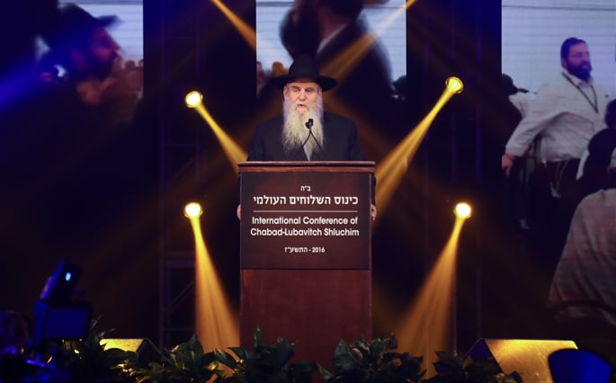

**Rabbi Moshe Kotlarsky became well-known for his role in the annual Kinus Hashluchim, or International Conference of Chabad-Lubavitch Emissaries. Photo** *Credit: Benams Photo*

While supporting her husband’s work and raising their large family, Rivka was constantly active in the Rebbe’s [mitzvah](https://www.chabad.org/library/article_cdo/aid/1438516/jewish/Mitzvah.htm) campaigns, and taught young women at the flagship Lubavitch women's school, Beth Rivkah. Her Crown Heights home served as homebase for Jews from Belgrade to Taipei, who knew they could always find an open door.

During his travels on behalf of the movement, Rabbi Kotlarsky would meet with the leaders and members of local Jewish communities, listening to them attentively and carefully considering their needs. Did they have Jewish education for their children? A functioning mikvah? Access to kosher food? Kotlarsky would assess all these factors and suggest ways that [Lubavitch](https://www.chabad.org/library/article_cdo/aid/244369/jewish/About-Chabad-Lubavitch.htm) could assist them to strengthen their community. In some cases, they would ask that Chabad send an emissary couple to help them. All of this Kotlarsky would put into a detailed report for the Rebbe’s review.

Kotlarsky went wherever he was needed, sometimes not even knowing why he was being sent.

**“The Rebbe Wants You to**

**Go to Curacao Immediately”**

Like the time in January of 1984 that he got a phone call at home from Rabbi Chaim Mordechai Aizik Hodakov, the Rebbe’s chief of staff, telling him, “the Rebbe wants you to go to Curacao immediately.” Upon arrival to the Caribbean island with a friend, they promptly hailed a taxi to the synagogue. However, instead of taking them to the famed Mikveh Israel synagogue, the cab driver took them to another, much smaller one, from which a man was exiting. “We were sent here by the Lubavitcher Rebbe,” Kotlarsky told the man.

The man, named Chaim Groisman, nearly fainted. Groisman, it emerged, was a local Jew whose family was going through a crisis. Their son, Eli, was being harassed in his Protestant school for not attending mandatory religious services. It got so bad that they started keeping him home from school, only to receive warning letters that by law they had to send him to school. The Groismans did not know what to do.

One night Chaim Groisman had a dream in which his late grandmother appeared and told him that if ever there was a time he was in trouble, he should turn to the [Lubavitcher Rebbe](https://www.chabad.org/therebbe/default_cdo/jewish/TheRebbeorg.htm). He’d never heard of the Rebbe before. The next day Kotlarsky and his traveling companion showed up.

“Rabbi Kotlarsky invited me to go to New York and attend Camp Gan Israel in the Catskills that summer, and later to [Yeshivah](https://www.chabad.org/library/article_cdo/aid/4407857/jewish/What-Is-a-Yeshiva.htm) that started in September,” [Eli Groisman recalled](https://www.chabad.org/therebbe/article_cdo/aid/133497/jewish/A-Jew-in-Curacao.htm). “This was the answer to our prayers, and I accepted the offer immediately.”

Groisman later wrote a letter of thanks to the Rebbe for sending his emissaries and caring for “a small Jew from Curacao.”

“I must … take exception to your referring to yourself as ‘a small Jew from Curacao,’” the Rebbe wrote to him… [T]here is no such thing as a ‘small Jew,’ and a Jew must never underestimate his or her tremendous potential.”

For the rest of his life Kotlarsky would cite these words from the Rebbe as a source of personal guidance and inspiration.

**Partnerships**

It was on one of his travels, this time to Bogota, Colombia, that he met Jewish businessman Sami Rohr. Their friendship quickly blossomed, and by the late 1970s a regular visitor to the Kotlarsky’s Crown Heights home was Sami’s son, a young recent graduate from Harvard named George. The extended Rohr family would go on to partner with Chabad and provide seed money and ongoing support to hundreds of Chabad centers and thousands of Chabad programs—bringing the Rebbe’s vision of a Jewish renaissance to college campuses, the former Soviet Union and communities all over the world.

**“Nu, Rabbi Kotlarsky? Did You Bring**

**Me Some New ‘Business’ Today**

“I will never forget when I visited him in the hospital just days before he passed away,” Kotlarsky [wrote about Sami Rohr](https://www.chabad.org/library/article_cdo/aid/2280897/jewish/7-Life-Lessons-Don-Sami-Taught-Me.htm). “His first words to me were, ‘Nu, Rabbi Kotlarsky? Did you bring me some new ‘business’ today?’”

Kotlarsky heavily expanded Chabad’s [rabbinical visitation program, which sees](https://www.chabad.org/library/article_cdo/aid/705977/jewish/Visitation-Programs.htm) rabbinical students fan out across the globe during the summer break and other times of the year; helped found [Chabad on Campus International](https://www.chabad.org/jewish-centers/118590/Brooklyn/Campus-Chabad-House/Chabad-on-Campus-International) and the [Rohr Jewish Learning Institute](https://www.chabad.org/jewish-centers/246082/Brooklyn/Jewish-Learning-Institute/The-Jewish-Learning-Institute), both of which he chaired; and spearheaded an array of additional initiatives, including CTeen, CKids, Chabad Young Professionals and Chabad on Call.

At this year’s Kinus, during his annual report on Chabad’s massive expansion during the past year, Kotlarsky reiterated, as he always did, that it was not a time to rest.

**If Only One Jew Has Not Been Touched**

**...The Mission in Incomplete**

“We know we have a great deal of work still ahead,” [he said](https://www.chabad.org/multimedia/video_cdo/aid/6171577/jewish/A-Call-to-Action.htm). “The Rebbe once said, you could have 1,000 people in your community. If only 999 have been touched and one wasn’t … the mission has not yet been accomplished.”

In addition to his wife, Rivka, he is survived by his children Chanie Wolowik (Woodmere, N.Y.); Rabbi Mayer Kotlarsky (Boca Raton, Fla.); Sarah Benjaminson (Glenview, Ill.); Nechama Greenberg (Vista, Calif.); Rabbi Mendy Kotlarsky (Brooklyn, N.Y.); Rabbi Sruly Kotlarsky (Lafayette Hill, Penn.); Rabbi Levi Kotlarsky (Brooklyn, N.Y.); Rabbi Dovid Kotlarsky (Chicago, Ill.); Goldie Perlstein (Gainesville, Virg.); and many grandchildren and great-grandchildren.

*Reprinted from the current website of Chabad.Org*

**Rav Avigdor Miller on What is**

**The Greatest Zechus One Can Have**

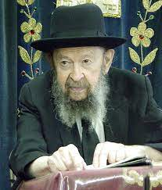

By means of being nitpal l’osei mitzvah - taking part in a Mitzvah endeavor, you can achieve the greatest of merit. Zechus harabim means benefiting the public spiritually and it’s one of the greatest things that can be done.

I’ll quote to you what the Chovos Halevavos says of this great deed of helping bring the public back to Judaism, back to avodas Hashem.

He says like this: “No matter how perfect you are in all the forms of shleimus, in every kind of perfection, it is as nothing compared to the perfection that comes from causing the multitude to become virtuous.” And he explains that it’s because all of their subsequent good deeds are credited to your account. Zechus harabim pays off very well in the World to Come!

But you think “What can I do already? I’m a simple Jew in Flatbush; I don’t have influence I don’t have money.” But we’re learning tonight that by looking to join others who are performing good things there’s always something you can do. There are ways and means of doing good things, only that you have to have an interest in it. You have to be interested in wanting to join in.

Now if you do that, so you’ve joined in to the great project of the Am Yisroel of trying to bring back our lost brothers. So, when you hear about good things being done so you think, “Ah! It’s a very good thing.” You have to express happiness about it. Think, “Yes, I’m full of simcha that they did it.”

Of course, if you can send five dollars, or a bigger contribution, even better. And Hakodosh Boruch Hu gives you credit for joining in with them.

*Reprinted from an email of Toras Avigdor, based on the teachings of Rav Avigdor Miller, zt”l. Adapted from (Parshas Bamidbar 5784)*

**Rabbi Berel Wein on**

**Parshat Nasso 5784**

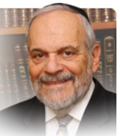

The idea of the *nazir* always raises questions and problems. The idea of monasticism is certainly not a basic Jewish value. Just the opposite seems to be true from the ideas and statements of the rabbis in the Talmud and from Jewish societal behavioral patterns over the centuries.

Jewish society, in its divisions and manifestations is vitally and socially gregarious to the extreme, with a brashness of involvement in all fields of human endeavor, thought and progress. Yet the Torah describes for us quite clearly and vividly the necessity for some necessity of monasticism, be it permanent or temporary, in Jewish life and social order.

Yet even this monastic situation is not meant to separate the *nazir* from active participation in communal life. *Shimshon*, the prime example of the *nazir*in our *Tanach* is nevertheless the leader of Israel, its chief judge and commanding warrior. There are halachic restrictions placed upon the *nazir* but locking himself away from Jewish society is certainly not one of them. There are restrictions regarding retaining purity and cutting one’s hair, avoiding any sorts of defilement and on consuming wine and affiliated beverages.

These restrictions amongst others certainly remind the *nazir* of his special status, but the *nazir* is still positively a member of the general society in all senses of participation in normal human life. If anything, a *nazir* now becomes a model for others for the attempt to achieve probity and purity in a world of the impure and sometimes wicked. So even though the rabbis are not happy with someone becoming a *nazir, neziirim*and *nezirut* are a necessary piece of the human puzzle that the Torah describes for us.

The Talmud also teaches us that the impetus for becoming a *nazir* is also societal. It stems not from the inner wish of the individual to forego certain pleasures and norms of life as much as it stems from the wish for a protective shield from the dissoluteness and licentiousness of the surrounding society. Apparently, in a perfect world, the whole concept of nezirut would be unnecessary. But the Torah judges human life, even Jewish life, as it really is in our imperfect world and not as it should somehow be. And, therefore, the *nazir* becomes a necessary ingredient in our Torah society.

Over the ages there have been outstanding people who have chosen the way of the *nazir* for themselves in their lifetimes. However, the reticence of the rabbis and Jewish tradition on this matter has prevented *nezirut* from becoming widespread or even accepted behavior. The Torah does not seek to impose burdens upon one’s life as much as it intends to guide and temper our choices and behavior within the framework of a wholesome complete life. This is also part of the lesson of the *parsha* of *nazir* to us. In essence, by knowing that becoming a *nazir* is an acceptable last resort in dealing with immorality and heartbreak, we can avoid this by living daily according to Torah precepts and values and shunning foreign and immoral influences in our lives and communities.

Shabbat shalom

*Reprinted from the current website of rabbiwein.com*

**The Significant Difference Between Viduy and Teshuva**

**From the Teachings of the Lubavitcher Rebbe**

**Rabbi Menachem Mendel Schneerson, Zt”l**

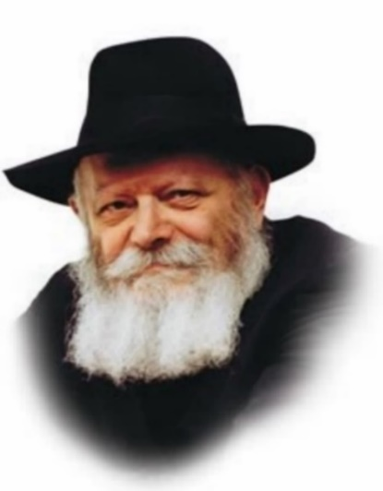

This week's Torah portion, Naso, contains the commandment: "Then they shall confess their sin which they have done." This is the mitzva of viduy (confession), about which Maimonides writes, "We are commanded to confess the sins and transgressions we have committed before G-d, after we have repented of them."

The mitzva of viduy is one of the Torah's 613 commandments, "Positive Commandment Number 73" in Maimonides' Sefer HaMitzvot. This raises a question: Why does Maimonides consider confession - which is only one component of teshuva (repentance) - a separate mitzva, whereas teshuva itself is not enumerated?

There are several explanations:

Repentance is not counted as one of the 613 mitzvot because there is no actual commandment in the Torah to repent. If a person wishes to do teshuva and rectify his sins the Torah shows him how, but he is not commanded to do so. Thus, confession is a mitzva, but teshuva is not.

Teshuva is an inner arousal and urge to return to G-d that arises in an individual. It therefore cannot be ordered from Above, for if it were, the command itself would compel the person to obey, and it would not be initiated entirely by the individual. Accordingly, the Torah does not command us to repent because G-d wants us to do it on our own.

Because teshuva is a "general" command, pertaining to the overall observance of Torah and mitzvot, it is not considered an individual mitzva, i.e., one of the 613. The Torah's 613 commandments are likened to the 613 organs and sinews in the human body. In the same way that only individual organs are counted in the total (whereas blood, which flows throughout the body, is not considered an organ), so too is repentance, an inner arousal of the heart, too generalized to be considered a separate mitzva.

Confession and repentance comprise a single mitzva. Maimonides writes that "Anyone who confesses but does not resolve to abandon [his sin] is like a person who immerses [in a mikva] while holding a rodent." Whenever a mitzva consists of two parts, one practical and the other emotional, only the practical component is included in the enumeration of mitzvot. For this reason, only oral confession is counted as a mitzva, whereas repentance, which involves the heart, is not.

According to this last explanation (which also follows Maimonides' interpretation) repentance is a mitzva, but it is included in the commandment of confession. Indeed, while teshuva is above all other mitzvot, we mustn't allow it to remain "up there," but must make sure that it permeates and enriches all of our observance.

*Reprinted from the Parashat Naso 5761/2001 edition of L’Chaim, a publication of the Lubavitch Youth Organization in Brooklyn. Adapted from Volume 38 of Likutei Sichot.*

**Thoughts that Count**

*The L-rd make His face shine upon you...the L-rd lift up His countenance to you* (Num. 6:25-26)

It is written in the holy Zohar that the letters of G-d's Name engraved on the golden plate on the High Priest's headdress were luminous. Anyone looking at them was filled with awe; this created an arousal to return to G-d in repentance, and the person's sins would be atoned for. In other words, through the luminous letters ("the L-rd make His face shine") the Jews repented (allowing G-d's countenance to be "lifted up"), and their sins were forgiven. *(Kotnot Or)*

*Reprinted from the Parashat Naso 5761/2001 edition of L’Chaim, a publication of the Lubavitch Youth Organization in Brooklyn*

**An Auspicious Night**

What happens when two tzaddikim and mekubalim of the stature of Reb Shlomo Alkabetz and Rav Yosef Caro spend the awesome night of Shavuos together? The answer is recorded in a 16th-century manuscript written by R. Shlomo Alkabetz:

“The Beis Yosef and I decided to stay awake on the night of Shavuos and read passages of the Torah. [These passages are the basis of what later became the Tikkun Leil Shavuos.] After chatzos, as we reached the section of Mishnayos, a sweet voice was heard aloud from the mouth of the Beis Yosef.

“We all fell on our faces from sheer fright. The voice grew ever louder, until even the neighbors were able hear it, though they were unable to understand it. The voice, having been created by the Mishna we had learnt, told us of the pain suffered by the Shechina [in exile], and the great impact our learning this night had, silencing all the Malochim and piercing all the heavens. It then spoke of our great zechus of staying awake this night, and the greater effect it would have had with a minyan.

**The Pain of the Shechina**

“The voice then encouraged us to continue learning throughout the night, not wasting even a moment. Finally, the Shechina instructed us to stand up and say Boruch Shem... aloud, as is done on Yom Kippur. We wept profusely, from the joy of our experience and for the pain of the Shechina.

“When we met three other chachomim in the mikve the next morning, we related to them what had happened that night. They were understandably distressed, and we resolved to gather again on the second night, this time with a minyan.

“That night, because of our joy at having a minyan, the voice of the Shechina began speaking as soon as we started reading the Aseres HaDibros of Devarim. The voice praised our attainment, told us of the ruchnius’dike fire surrounding the house, and then directed us to say Boruch Shem. As the time of chatzos drew near, the Shechina spoke again and told us that for hundreds of years no such accomplishment had been attained.”

The Shaloh HaKadosh copied this story from the manuscript of Reb Shlomo Alkabetz and concluded: “It is apparent in his writing that there was much more that he was not allowed to reveal. From this story we must learn how important it is to conduct ourselves with a special kedusha on this night.” של"ה הקדוש מס' שבועות נר מצוה ה'

*Reprinted from the Shavuous 5784 edition of The Weekly Farbrengen.*

**More Thoughts that Count**

*And the one who offered his offering on the first day ("bayom harishon") was Nachshon the son of Aminadav, of the tribe of Judah* (Num. 7:12)

Each letter in the Hebrew alphabet has a numerical value. The sum of "bayom harishon" is 620, which is the same as "keter," crown. This alludes to the fact that Judah, the tribe to which Nachshon belonged, was the progenitor of the Jewish monarchy (including Moshiach, a descendant of King David). *(Ohr HaTorah)*

*The princes of Israel... brought their offering before the L-rd* (Num. 7: 2-3)

Although each of the 12 princes brought exactly the same things, the Torah enumerates their offerings separately. This is because the offerings were only the same externally; on the spiritual level, each prince made his offering in a way that was specific to the Divine Source of his tribe, drawing down Divine illumination to its members. "And even today, when the particulars of these sacrifices are read in the Torah, this nullification [before G-d] is drawn down to each and every tribe." *(Likutei Torah)*

*Reprinted from the Parshas Naso 5761/2001 edition of L’Chaim, a publication of the Lubavitch Youth Organization in Brooklyn.*